1.Cmake例子

<http://blog.csdn.net/dbzhang800/article/details/6314073>

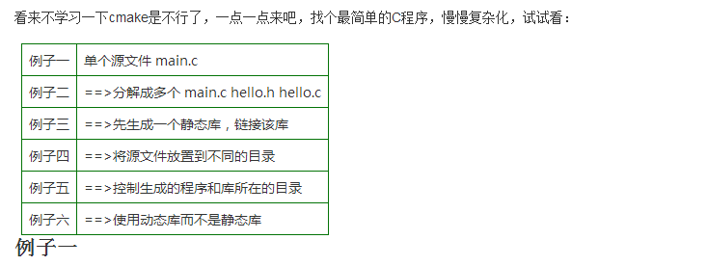

2.Qt和VTK混合

<http://blog.csdn.net/dedje/article/details/42025143>

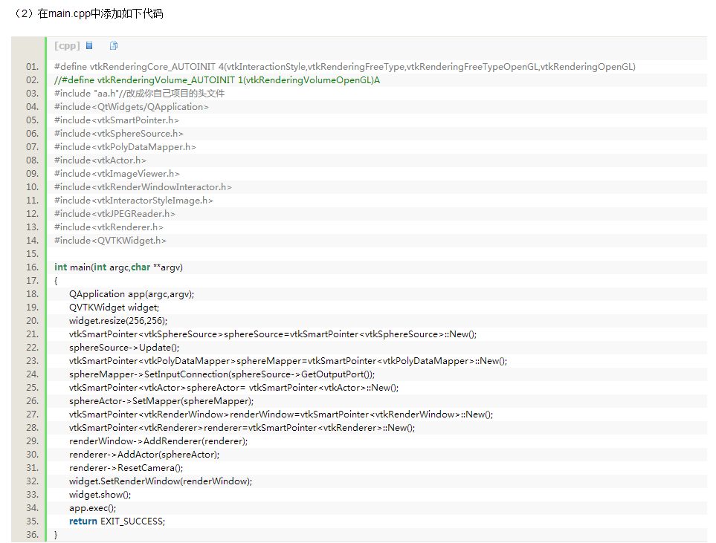

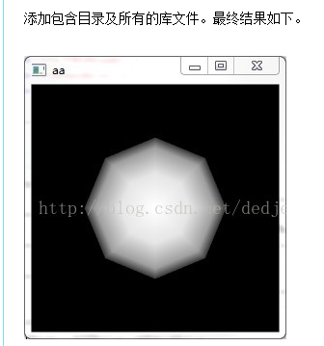

1. 编译第三方库

（1）MathFunctions

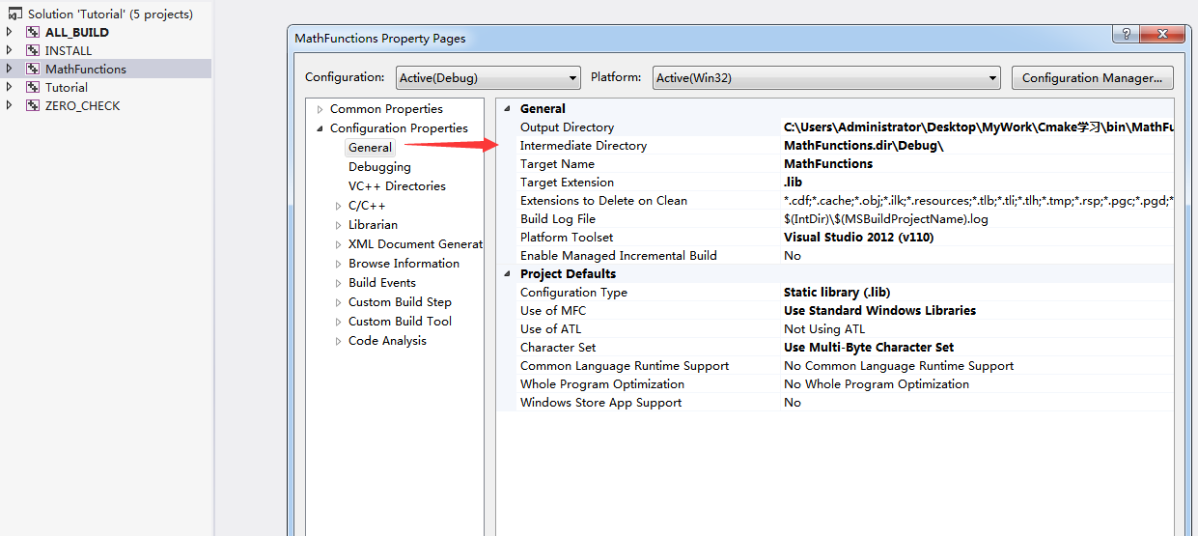

1. Install

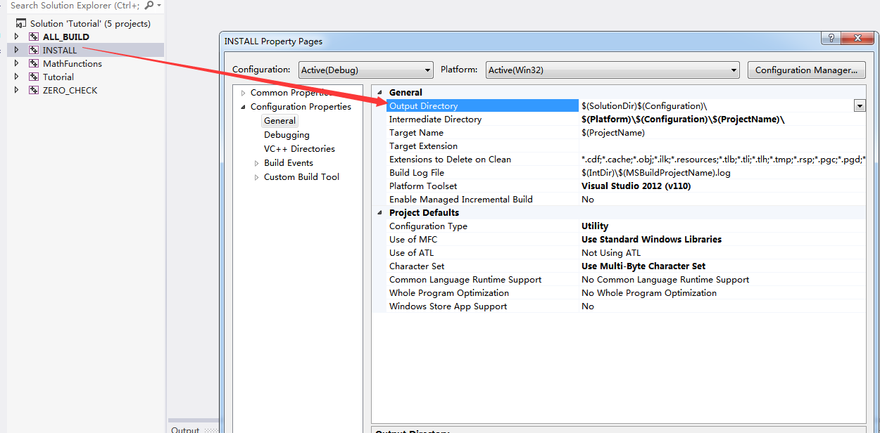

3.Cmake设置输出目录

（1）设置Debug和Release的输出路径

Set( CMAKE_RUNTIME_OUTPUT_DIRECTORY_DEBUG ../__Out/Win32/Debug/Bin ) #Debug的输出路径

Set( CMAKE_RUNTIME_OUTPUT_DIRECTORY_RELEASE ../__Out/Win32/Release/Bin ) #Releas的输出路径

（2）设置编译选项

set(CMAKE_CXX_FLAGS_DEBUG "/MTd") #设置Debug采用MTd

set(CMAKE_CXX_FLAGS_RELEASE "/MT") #设置Release采用MT

SET(CMAKE_MFC_FLAG 1) #设置使用 静态MFC共享库

add_definitions(-DUNICODE -D_UNICODE) #设置字符集为Unicode

**（3）设置可执行文件的输出路径**

Set( EXECUTABLE_OUTPUT_PATH ${PROJECT_SOURCE_DIR}/../bin) 设置可执行文件的输出目录

在win+vs下回自动在你所设置的目录后面增加扩展

${ PROJECT_SOURCE_DIR}/../bin/Debug

${PROJECT_SOURCE_DIR}/../bin/Release

（4）设置库文件的输出目录

Set( LIBRARY_OUTPUT_PATH ${PROJECT_SOURCE_DIR/../lib} )

（5）设置debug和release库文件的输出目录

Set( CMAKE_ARCHIVE_OUTPUT_DIRECTORY_DEBUG ${PROJECT_SOURCE_DIR}/../lib )

Set( CMAKE_ARCHIVE_OUTPUT_DIRECTORY_RELEASE ${PROJECT_SOURCE_DIR}/../lib )

（6）设置debug版和release版下库文件的后缀名

Set( CMAKE_DEBUG_POSTFIX “_d”)

Set( CMAKE_RELEASE_POSTFIX “_r”)

（7）设置Debug和Release版下可执行文件的后缀名

Set_target_properties( ${TARGET_NAME} PROPERTIES DEBUG_POSTFIX “_d” )

Set_target_properties( ${TARGET_NAME} PROPERTIES RELEASE_POSIFIX “_r”) #这两个命令测试没有成功？？？